Task-1 Lab-01

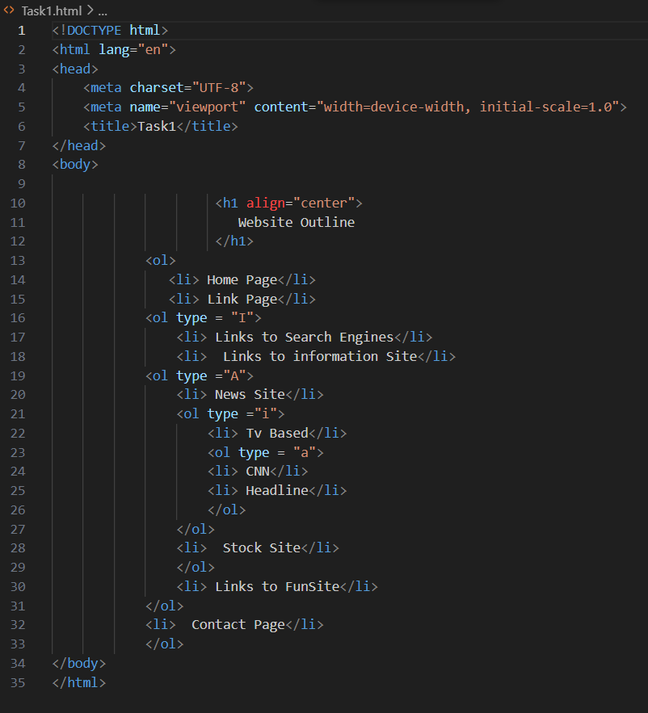

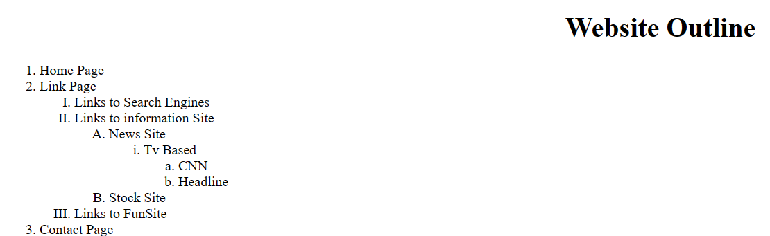

Task-2

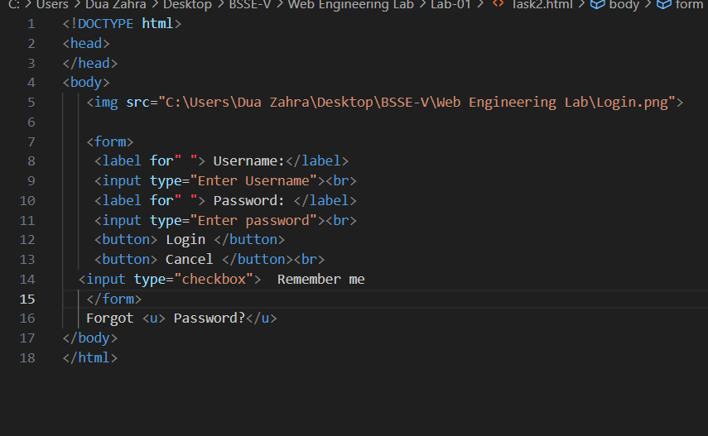

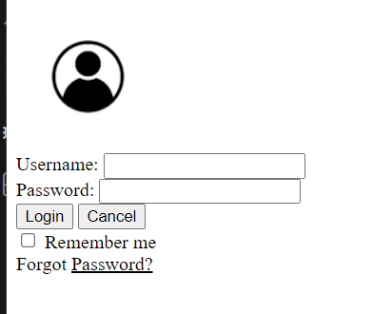t

Task-3

<!DOCTYPE html>

<html>

<head>

    <style>

      table,  th,td{

        border: 1px solid black;

      }

    </style>

</head>

<h1> Using Rowspan</h1>

<table border="1px" width="400" height="100">

<td Rowspan= "4"> UserInfo

<tr>

    <th> 1</th>

    <th> John Carter</th>

    <th> johncarter@mail.com</th>

</tr>

<tr>

    <th> 2</th>

    <th> Peter Parker</th>

    <th> peterparker@mail.com</th>

</tr>

<tr>

<th> 3</th>

<th> John Rambo</th>

<th> johnrambo@mail.com</th>

</tr>

</td>

</table>

<br>

<h2>  Using Colspan</h2>

<table border="1px" width="400" height="100">

<th colspan= "3"> UserInfo </th>

    <tr>

        <td> 1 </td>

        <td> John Carter</td>

        <td> johncarter@mail.com</td>

    </tr>

    <tr>

        <td> 2 </td>

        <td>  Peter Parker</td>

        <td> peterpaker@mail.com</td>

    </tr>

    <tr>

        <td> 3 </td>

        <td>  John Rambo</td>

        <td> johnrambo@mail.com</td>

    </tr>

</table><br><br>

<table style="width:20;">

    <tr>

        <th  colspan="2"> </th>

        <th> Fruits Juice Drinks</th>

    </tr>

    <tr>

        <td> Apple</td>

        <td> Orange</td>

        <td> ScewDriver</td>

    </tr>

    <tr>

        <td> 0</td>

        <td> 1</td>

        <td> 0</td>

    </tr>

    <tr>

        <td> 1</td>

        <td> 0</td>

        <td> 0</td>

    </tr>

    <tr>

        <td> 0</td>

        <td> 0</td>

        <td> 1</td>

    </tr>

</table>

</html>

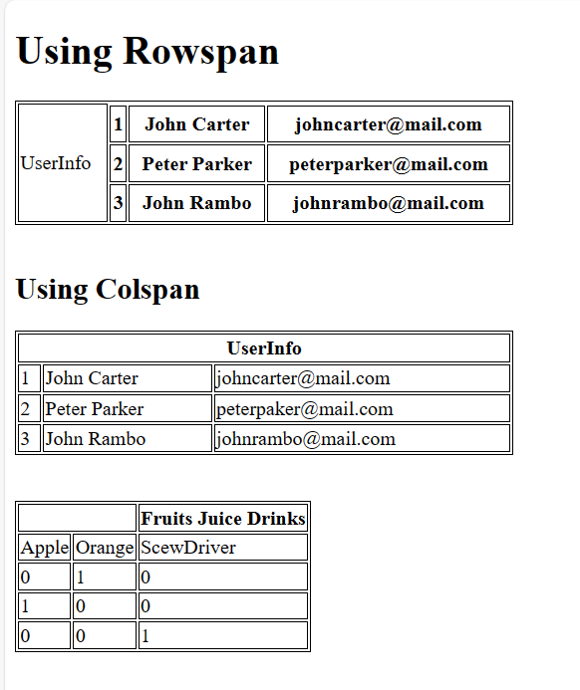

Task-4

<!DOCTYPE html>

<head>

</head>

    <body>

<h1>

    This is Your First HTML Page

</h1>

<p><b> Seems like things are going pretty well so far</b></p>

<p> Let's add a recipe for some delicious  chocolate chip cookies </p>

<p> We are going to borrow a nice picture from General Mills   </P>

<img src ="C:\Users\Dua Zahra\Desktop\BSSE-V\Web Engineering Lab\Biscuit.JPEG">

<p> here is the what the recipe calls for </p>

<p><b>Ingredients </b>(probabaly not right.....)</p>

<ul>

    <li> 6 Eggs </li>

    <li> 2 cups of flour</li>

    <li>  2 TableSpoons of Vanilla extract </li>

    <li> 2 Teaspoons of baking powder</li>

    <li> 1 Cup of Sugar</li>

</ul>

<p> <b> Instructions </b> (may or may not be correct)</p>

<ol>

    <li> Add eggs, flour,and vanilla extract and mix</li>

    <li> Combine with Sugar and baking powder and stir</li>

    <li> Eat half the cookie batter because it is delicious </li>

    <li> Take the rest of cookies batter and make cookies </li>

    <li> Bake at 350 for 25 minutes </li>

    <li> Enjoy!</li>

</ol>

    </body>

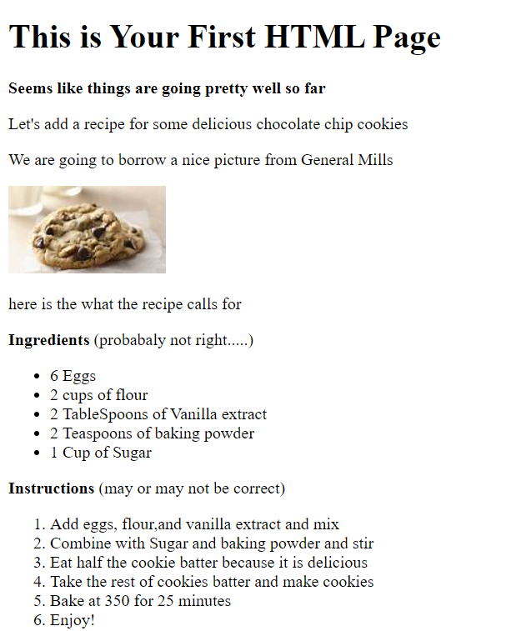

**Task 5**

<!DOCTYPE html>

<head>

</head>

<h1> Welcome to  Millennium Gymnastic  Booster Club PopCorn Sales</h1>

<form>

    <label for""> Buyer's Name: </label>

    <input type ="Enter buyer's name"><br>

    <label for "">Street Address: </label>

    <input type ="Enter Address"><br>

    <label for""> City State Zip</label>

    <input type="Enter City State Zip"><br>

    <table>

        <tr>

          <th>Product Name</th>

          <th>Price Quality</th>

        </tr>

        <tr>

          <td>Unpoped popcorns(1lb) </td>

          <td>

          <label for ""> 3:00</label>

        <input type="price"><br></td>

        </tr>

        <tr>

            <td>Caramel popcorns(1lb) </td>

            <td>

            <label for ""> 3:50</label>

          <input type="price"><br></td>

          </tr>

          <tr>

            <td>Caramel nut popcorns(1lb) </td>

            <td>

            <label for ""> 4:50</label>

          <input type="price"><br></td>

          </tr>

          <tr>

            <td>Tofee nut popcorns(1lb) </td>

            <td>

            <label for ""> 5.00</label>

          <input type="price"><br></td>

          </tr>

        </table>

    <h2> Payment Method </h2>

    <input type="radio" id="Visa" name="Visa" value="Visa">

    <label for="Visa">Visa</label><br>

    <input type="radio" id="master card" name="master card" value="master card">

    <label for="master card">master card</label><br>

    <input type="radio" id="Disccover" name="Disccover" value="Disccover">

    <label for="Disccover">Disccover</label><br>

    <input type="radio" id="Cheque" name="Cheque" value="Cheque">

    <label for="Cheque">Cheque</label><br>

    <button> submit order  </button>

    <button>  clear order form </button>

    </form>

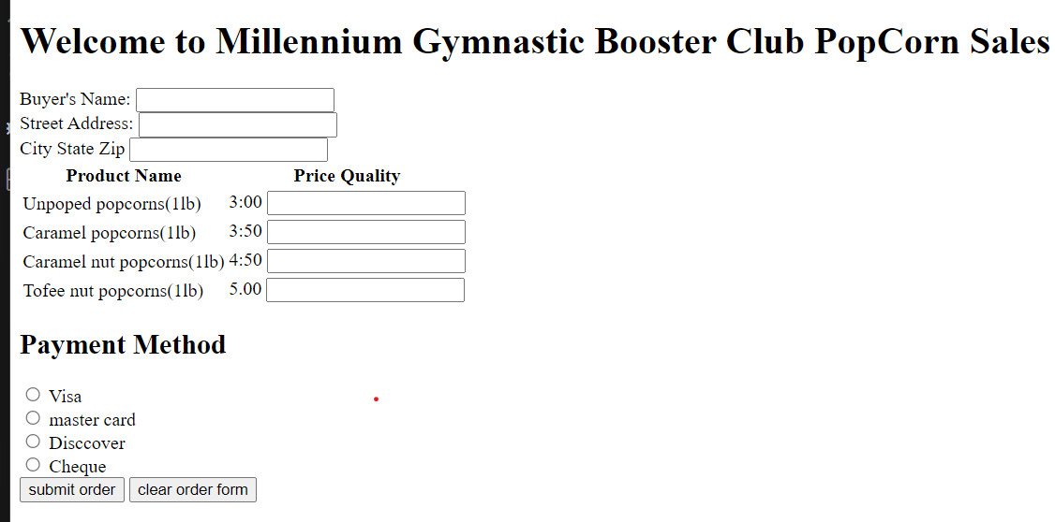

**Task-6**

<!DOCTYPE html>

<html >

<head>

    <style>

        table , th , td{

            border: 2px solid black;

        }

    </style>

</head>

<body>

    <table border="2px" width="50" height="200">

       <th> <img src="C:\Users\Dua Zahra\Desktop\BSSE-V\Web Engineering Lab\SIBA_Logo.JPG" alt="SIBA_Logo" width="20" height="30" >

        <th colspan="22">Teacher Muhammad Fahad Shahzad (VF)</th><br><br></th>

        <tr>

            <th rowspan="1"></th>

            <th colspan ="2">1<br>9:00 9:50Am</th>

            <th colspan="2">2<br>9:50 10:40AM</th>

            <th colspan="2">20mints break<br> 10:40 11:00Am</th>

            <th colspan="2">3<br>11:00 11:50Am</th>

            <th colspan="2">4<br>11:50 12:40PM</th>

            <th colspan="2">20mints break 12:40 1:00PM</th>

            <th colspan="2">5<br>1:00 1:50PM</th>

            <th colspan="2">Lunch Break<br>1:50 2:20PM</th>

            <th colspan="2">6<br>2:20 3:10PM</th>

            <th colspan="2">7<br>3:15 4::05PM</th>

            <th colspan="2">8<br>4:10 5:00PM</th>

        </tr><br>

        <tr>

            <th colspan="1">Mo</th>

            <td colspan="2"></td>

            <td colspan="2"></td>

            <td colspan="2"></td>

            <td colspan="2"></td>

            <td colspan="2"></td>

            <td colspan="2"></td>

            <td colspan="2"></td>

            <td colspan="2"></td>

            <td colspan="2"></td>

            <td colspan="2"></td>

            <td colspan="2"></td>

        </tr><br>

        <tr>

        <th colspan="1">Tu</th>

        <td colspan="2"></td>

        <td colspan="2"></td>

        <td colspan="2"></td>

        <td colspan="2"></td>

        <td colspan="1">BS-VII(CS)<br>Enterprise<br>Application<br>Development</td><br>

        <td colspan="2"></td>

        <td colspan="2"></td>

        <td colspan="1">BS-VII(CS)<br>Enterprise<br>Application<br>Development</td><br>

        <td colspan="2"></td>

        <td colspan="1">BS-VII(CS)<br>Enterprise<br>Application<br>Development</td><br>

        <td colspan="2"></td>

        <td colspan="2"></td>

        </tr><br>

        <tr>

            <th colspan="1">We</th>

                <td colspan="2"></td>

                <td colspan="2"></td>

                <td colspan="2"></td>

                <td colspan="2"></td>

                <td colspan="2"></td>

                <td colspan="2"></td>

                <td colspan="2"></td>

                <td colspan="2"></td>

                <td colspan="2"></td>

                <td colspan="2"></td>

                <td colspan="2"></td>

        </tr><br>

        <tr>

            <th colspan="1">Th</th>

            <td colspan="2"></td>

            <td colspan="2"></td>

            <td colspan="2"></td>

            <td colspan="2"></td>

            <td colspan="2"></td>

            <td colspan="2"></td>

            <td colspan="2"></td>

            <td colspan="2"></td>

            <td colspan="2"></td>

            <td colspan="2"></td>

            <td colspan="2"></td>

        </tr>

        <tr>

            <th colspan="1">Fr</th>

            <td colspan="2"></td>

            <td colspan="2"></td>

            <td colspan="2"></td>

            <td colspan="2"></td>

            <td colspan="2"></td>

            <td colspan="2"></td>

            <td colspan="2"></td>

            <td colspan="2"></td>

            <td colspan="2"><B>BS-VII(SE)-A<br>Enterprise<br>Application<br>Development</B></td>

            <td colspan="2"><B>BS-VII(SE)-A<br>Enterprise<br>Application<br>Development</B></td>

            <td colspan="2"><B>BS-VII(SE)-A<br>Enterprise<br>Application<br>Development</B></td>

        </tr>

    </table>

</body>

</html>

